Prelab 5b

Yujian An

3 Pre-LabRecall the MagLev system from last week’s lab and the values of the linearized model you have determined during the system identification.  
1. Plot the root locus and frequency response of your system and explain what you see. Is the system stable or unstable?

G(s)===

Root locus:

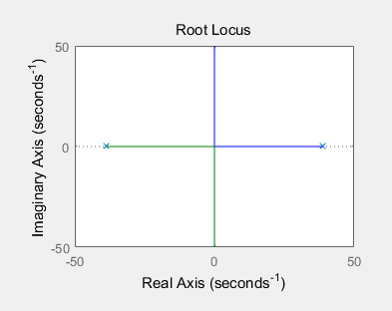

frequency response

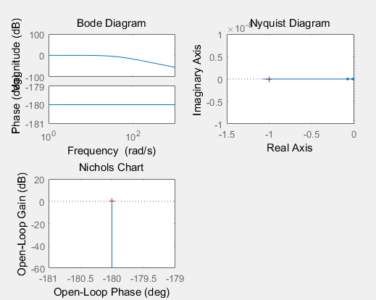

It only have 2 poles which are on the jw axis, so it’s (marginally) stable.

2. We will be adding a controller of the form G*c*(s) = to improve the performance of our system. Depending on the pole and zero locations, the compensator can be referred to as either a Lead or Lag compensator. This will be elaborated upon in later classes.

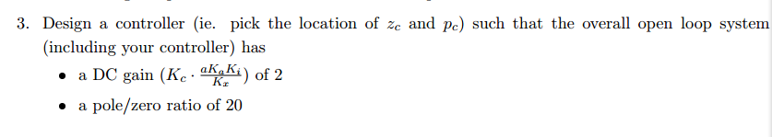

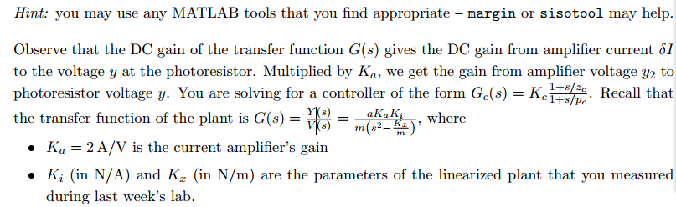

a, Ka, Ki and Kx are already known, wo make DC gain=2, we need to have a Kc= 0.93

and to satisfy pole/zero ratio is 20, I choose zero= -1 and pole= -20

The system is stable now, because when K=0.93, all poles are on the left hand of plane.

4. Using your derivations from last week’s Pre-Lab, calculate the values of R*1*, R*2*, and C to use in your circuit

C:\Users\ThinkPad\Documents\Tencent Files\879401635\FileRecv\MobileFile\Image\5U7_~{0VU)L~]B4`J)TE4%W.png

So R1==10.8KΩ and for =20\*, so 19R1=R2, so R2=204KΩ

And for = 20, so C=0.25μF.